**KNOWLEDGE, ATTITUDE, AND PRACTICES OF HPV VACCINATION AMONG MOTHERS OF PRE-TEEN AGE GIRLS ATTENDED TO AT KITALE COUNTY REFERRAL HOSPITAL.**

Juliet Sisso - HSM211-0073/2018

Benter Achieng - HSM211-0324/2017

Gibson Kiteki - HSM211-0069/2018

Margaret Njambi-HSM211-0197/2016

Patrick Kisio-HSM211-0064/2017

Department of Clinical Medicine, Jomo Kenyatta University of Agriculture and Technology Research

Dr. Michieka

**THIS PROJECT IS SUBMITTED IN PARTIAL FULFILLMENT OF THE AWARD OF A BACHELOR'S DEGREE IN CLINICAL MEDICINE AND COMMUNITY HEALTH AT THE DEPARTMENT OF CLINICAL MEDICINE AT JOMO KENYATTA UNIVERSITY OF AGRICULTURE AND TECHNOLOGY.**

**APRIL 2023**

# DECLARATION AND APPROVAL

We declare that this research paper represents our original work and that all sources used in this study have been duly acknowledged and cited according to the appropriate referencing style. The research reported in this paper was conducted per the ethical principles and guidelines and all necessary permissions and approvals for using any copyrighted material included in this paper have been obtained. Furthermore, we take full responsibility for any issues that may arise from the use of this research paper. We understand that any violation of academic integrity, such as plagiarism or data falsification, may result in disciplinary action, including the revocation of any academic degrees earned. Signature Date

Benter Achieng ______________ ____________

Gibson Kiteki ______________ ____________

Patrick Kisio ______________ ____________

Margaret Njambi ______________ ____________

Juliet Sisso ______________ ____________

This proposal has been submitted for examination with my approval as university supervisor.

Dr. Michieka Nyariki

Signature Date

___________ __________

# DEDICATION

We dedicate this research project to the young girls of the next generation with the hope that our findings will contribute to a reduction in cervical cancer cases in the future. May this research help to improve the knowledge, attitudes, and practices of HPV vaccination among mothers of pre-teen age girls attended at Kitale County Referral Hospital. Additionally, we dedicate this project to Jomo Kenyatta University of Agriculture and Technology for allowing us to undertake this research and nurturing our academic growth.

# ACKNOWLEDGEMENT

We would like to express our sincere gratitude to our supervisor, Dr. Michieka Nyariki, for his invaluable guidance, support, and encouragement throughout the project. His expertise and insights were critical in shaping our research proposal. We would also like to acknowledge our group members, who worked tirelessly, offering invaluable insights and support at every stage of the research process.

We also extend our gratitude to the Department of Clinical Medicine for making this research possible. We are grateful for their resources and support, which helped us achieve our objectives. Finally, we would like to acknowledge the study participants who took their time to share their knowledge, attitudes, and practices regarding HPV vaccination.

# ABBREVIATIONS AND ACRONYMS

HPV - Human papillomavirus

WHO - World Health Organization

STI - Sexually Transmitted Infections

CDC - Centre for Disease Control

KAP- Knowledge, attitudes, and Practices

Table of Contents

DECLARATION AND APPROVAL ii

DEDICATION iii

ACKNOWLEDGEMENT iv

ABBREVIATIONS AND ACRONYMS v

LIST OF TABLES ix

LIST OF FIGURES x

ABSTRACT xii

CHAPTER 1: INTRODUCTION 1

1.1 Background information 1

1.2 Statement of the problem 3

1.3 Justification 4

1.4 Research Questions 5

1.5 Broad Objective 5

1.6 Specific Objectives 5

CHAPTER 2: LITERATURE REVIEW 6

CHAPTER 3: RESEARCH METHODS AND MATERIALS 9

3.1 Study area 9

3.2 Study Design 10

3.3 Strengths and Limitations 10

3.4 Target Population 10

3.5 Sample Size 11

3.6 Sampling method 11

3.7 Inclusion and exclusion Criteria 12

3.8 Data collection 12

3.9 Data analysis 13

3.9 Ethical considerations 13

CHAPTER 4: RESULTS 14

4.1 Demographic features 14

4.2 Knowledge 15

4.3 Attitude 23

4.4 Practices 27

4.4 Correlation Between Different Variables 32

CHAPTER 5: DISCUSSION, CONCLUSION, CHALLENGES, and RECOMMENDATIONS 43

5.1 Discussion 43

5.2 Conclusion 48

5.3 Challenges 49

5.4 Recommendations 52

APPENDICES 53

Appendix I: Schedule of activities 53

Appendix II: Research Budget 54

Appendix III: Consent Form 55

Appendix IV: Questionnaire 56

REFERENCES 59

# LIST OF TABLES

Table 1Age of participants 14

Table 2Education level of participants 14

Table 3Marital status 15

Table 4Religion of participants 15

Table 5Heard of Human papillomavirus 16

Table 6Human papillomavirus transmission 16

Table 7Disease HPV causes 16

Table 8 Fears regarding HPV vaccine 24

Table 9 Willing to have more information 25

Table 10 Percentage recipients of HPV vaccine 28

Table 11 Number of HPV vaccine dose received 28

Table 12 Education level vs Disease HPV causes 32

Table 13 Education level vs receiving HPV vaccine 33

Table 14 Age vs level of education 34

Table 15 Religion vs receiving HPV vaccine 37

Table 16 Receiving HPV vs recommending to others 38

Table 17 Heard of HPV vaccine vs participating in surveys 38

Table 18 Knowing disease HPV causes vs receiving vaccine 39

Table 19 Declining HPV vaccination vs fears about the vaccine 40

Table 20 Heard of HPV vaccine vs daughter receiving vaccine 41

# LIST OF FIGURES

Figure 1Heard of HPV vaccine 17

Figure 2Disease HPV vaccine prevents 18

Figure 3Route of administration of HPV vaccine 19

Figure 4Age group recommended for HPV vaccine 19

Figure 5Number of HPV vaccine doses administered 20

Figure 6 Access to HPV vaccine 21

Figure 7 Efficacy to HPV vaccine 21

Figure 8 Enough information about HPV vaccination 22

Figure 9 Sources of information 22

Figure 10 Declining HPV vaccination 23

Figure 11 Reason for decliclining HPV vaccine 24

Figure 12 HPV vaccination in schools 25

Figure 13 Benefits of HPV vaccine outweigh risks 25

Figure 14 How important it is to vaccinate 26

Figure 15 Comfortability of discussing sexual life 26

Figure 16 Encountering barriers 27

Figure 17 Barriers to HPV vaccination 27

Figure 18 Reasons for not receiving second dose of HPV vaccine 29

Figure 19 Plan to vaccine in future 29

Figure 20 Asking Health care provide about HPV vaccination 30

Figure 21 Satisfaction with the process of HPV vaccination 30

Figure 22 Do you recommend HPV vaccine 31

Figure 23 Participation in surveys 31

Figure 24 Age vs declining HPV vaccine 35

Figure 25 Age vs receiving HPV vaccine 35

Figure 26 Marital status vs receiving HPV vaccine 36

Figure 27 Encountering barrier vs receiving HPV vaccine 39

Figure 28 Level of education vs comfort of discussing sexual life with daughter 41

Figure 29 Comfortability of discussing sexual life vs receiving HPV vaccine 42

# 

# ABSTRACT

Human papillomavirus (HPV) is a common sexually transmitted virus that causes cervical cancer, which is among the leading causes of cancer deaths among women in Kenya. HPV vaccination is a safe and effective way to prevent cervical cancer, but the vaccine uptake among pre-teen girls in Kenya is sub-optimal. This study aims to assess the knowledge, attitudes, and practices of mothers of pre-teen girls attending Kitale County Referral Hospital regarding HPV vaccination and to identify factors that influence their decision-making regarding the vaccination.

The study employed a cross-sectional design, using a structured questionnaire to collect data from a sample of mothers. The questionnaire covers knowledge about HPV, the vaccine, the benefits of vaccination, and attitudes toward vaccination and vaccine uptake. We did our analysis using Statistical Package for Social Sciences (SPSS), and chi-square tests was used to determine the association between different variables.

The data collected was presented in tables and pie charts, and expressed in frequencies and percentages. The results of this study has provided valuable insights into the level of awareness and acceptance of HPV vaccination among mothers, which has informed strategies to improve vaccination coverage in the target population.

Mothers participated in this research willingly and were allowed to withdraw at any time without penalty. Additionally, the data collected was strictly utilized for the purpose intended and held with the utmost confidentiality. Ethical clearance was sought from the Ethical office at Jomo Kenyatta University of Agriculture and Technology before data collection and was approved.

A total of 150 mothers participated in the survey. The finding of the study showed that majority of the mothers were between ages 35-45, which was 38.7%, and most of them had attained secondary level education, 42.7%. Fewer mothers (40%) had knowledge about HPV, and only 39.3% knew about the disease it caused.

Accordingly, only 34.7% knew the mode of transmission of the virus. Majorly, mothers who knew about HPV vaccination accumulated to 40.7%, and 38.7% of the mothers knew the disease it prevents. A significant portion of participants (38%) lacked a reliable source of information about HPV vaccination. A divide was seen in the population when it came to expressing fears.

A big portion (50.7%) expressed fears contributing to 14.7% declining the HPV vaccination for their daughter. This was due to misconceptions and lack of information leading this mothers to question the role and the safety of the vaccine. This could have attributed to the poor uptake of the vaccine as only 26% of the mothers had vaccinated their daughters. Also, barriers could have attributed to the low intake as a substantial portion of the mothers (58.3%) encountered barriers while trying to vaccinate their daughters. Among the mothers who faced barriers 28.6% did not vaccinate their daughters.

Notably, 14.7% of the mothers had participated in a HPV vaccine survey before and all of them (22) heard knowledge about the HPV vaccination. In conclusion, there is a gap in the knowledge of the mothers about HPV and HPV vaccination which led to the sub-optimal uptake of the vaccine.

The mothers also have misconceptions about the vaccine that can be addressed by increasing their knowledge about the vaccine. The government and the health care system should work hand in hand to increase exposure to information about the HPV vaccination, and ways to curb barriers that the mothers face when trying to vaccinate their daughters. This will increase the HPV vaccine uptake.

# CHAPTER 1: INTRODUCTION

## 1.1 Background information

Human Papillomavirus (HPV) is an acronym standing for human papillomavirus. It is among the most common sexually transmitted infections (STI). In 2018, there were about 43 million cases of HPV, many among individuals in their late teens and early 20s. The HPV virus has over 100 strains that can cause warts in different body parts, including feet, hands, and face.

There are also about 30 strains that can affect the genitals, including the vulva, vagina, anus, rectum, penis, and scrotum. HPV is spread by having sexual intercourse with an infected person. HPV poses a greater health risk to the female gender because it can progress to cervical cancer if left untreated.

Some strains of HPV (mostly 16 and 18) cause cervical dysplasia, a precancerous condition in which there is an abnormal growth of cells on the surface of the cervix. The abnormal cells then become cancer cells. In Kenya, cervical cancer accounts for 23% of all cancer cases and 12% of cancer-related deaths (Kenya National Bureau of Statistics [KNBS], 2019). This makes cervical cancer the second most common cancer in the country. However, cervical cancer is preventable through vaccination against HPV.

One of the main ways to prevent cervical cancer as part of a comprehensive strategy is to use the HPV vaccine along with safe sexual practices. HPV vaccination protects against some of the strains that cause cervical cancer e.g., HPV 16 and 18. Vaccination of girls between the ages of 9-14 with two doses of the HPV vaccine is recommended by the World Health Organization (WHO), with a minimum interval of six months between doses, as part of national vaccination programs (WHO, 2019).

The optimal age to get the vaccination is before sexual debut, usually pre-adolescent. Since 2019, Kenya has included the HPV vaccine in their national immunization program targeting girls aged 10 years (Ministry of Health, 2019). Despite the availability of the HPV vaccine in Kenya, the uptake of the vaccine is low. According to the Kenyan Ministry of Health, only 23% of girls aged 9-14 had received the HPV vaccine as of 2020 (Ministry of Health, 2020).

The sub-optimal uptake of vaccination is owed to various challenges. These include stigmatization of STIs, religious inclinations, child's age, societal norms, and access to the vaccine. Additionally, the need to involve the mother and the child in the decision and the knowledge and attitude of mothers with adolescent girls towards the vaccine affect vaccine uptake. Parental consent is required to vaccinate these minors.

Studies from various countries have shown that mothers' knowledge and attitudes toward HPV vaccination can affect their decision to vaccinate their daughters (Akbari et al., 2020; Javanbakht et al., 2016; Yilmazel et al., 2018).

Kitale Referral Hospital is a public hospital located in Kitale, Trans Nzoia County, Kenya. It provides comprehensive healthcare services, including vaccination to the residents of Trans Nzoia County and its environs.

However, there is limited information about the knowledge, attitudes, and practices of HPV vaccination among mothers of pre-teenage girls attending the hospital. This study aims to evaluate the understanding, beliefs, and behaviors of mothers with pre-adolescent daughters who received medical attention at the Kitale County Referral Hospital in Trans Nzoia County, Kenya, regarding HPV vaccination.

## 1.2 Statement of the problem

Human Papilloma Virus has been implicated as a cause of laryngeal, oral, lung, and anogenital cancer (Lynette Luria, 2022). Among these, cervical cancer is the leading cause of cancer deaths in women, with over 90% occurring in low-income countries like Kenya (Karanja Chege, 2022).

In 2020 Kenya reported over 5000 new cases of cervical cancer and about 3000 deaths from cervical cancer complications (Karanja Chege, 2022). HPV vaccine uptake has been suboptimal, with only 33% of the targeted population receiving the first dose in 2020 and 16% returning for the second dose (Karanja Chege, 2022). The low uptake can be attributed to a lack of knowledge and misinformation about immunization.

In Kitale County Referral Hospital, there’s a lack of data showing the education of mothers of pre-teen girls and a high number of girls past the maximum age for HPV vaccination who did not receive the vaccine points to sub-optimal uptake.

Information about the Knowledge, attitudes, and practices of mothers of pre-teen girls who attended Kitale County Referral Hospital will increase the uptake of the HPV vaccine since parental consent is one factor that influences vaccine uptake. It will also help the mothers with informed decision-making and change their attitudes toward vaccinating their girls, which are influenced by misinformation, lack of knowledge, and negative cultural beliefs.

## 1.3 Justification

HPV vaccine intake among pre-teen girls is very low, with only 10% of the target population completing the two-dose vaccination and about 35% completing the first dose in 2019 in Kenya (WHO, 2019).

These statistics are way below the WHO target of 90% of the target population being fully vaccinated by 2030. Mothers of these previous teen girls are the best conduit to contact pre-teens about HPV vaccines. Most of these mothers have poor knowledge, attitude, and practices about the HPV vaccine.

A few studies have documented reasons for the poor HPV vaccine intake among pre-teen girls in Kenya. These reasons must be identified, and a strategic plan must be implemented to address the issues.

In Kenya, knowledge, attitude, and practices on HPV have not even been fully studied and documented. The data about knowledge, attitude, and practices on HPV among mothers of pre-teen girls is inadequate, making it difficult for agencies to implement this program because they are unsure what to address at the community level.

The main objective of this study is to obtain information that could improve HPV vaccine coverage in Kenya. The data collected from mothers of pre-teen girls who attended Kitale County Referral Hospital will provide insight into the knowledge, attitude, and practices of HPV vaccine among mothers of pre-teen girls in Kenya. Consequently, the statistics deduced can help achieve the WHO Cervical Cancer Elimination Strategy Target for 2030, ensuring that 90% of all girls are fully vaccinated with the HPV vaccine by the age of 15 years.

## 1.4 Research Questions

1. What is the level of knowledge among mothers of pre-teen girls attending Kitale County Referral Hospital regarding HPV vaccination?
2. What are mothers' attitudes towards HPV vaccination for their pre-teen age daughters?
3. What are the current practices of mothers regarding HPV vaccination for their pre-teen age daughters?

## 1.5 Broad Objective

To assess the knowledge, attitude, and practices of HPV vaccination among mothers of pre-teen girls attended at Kitale County Referral Hospital.

## 1.6 Specific Objectives

1. To determine the level of knowledge among mothers of pre-teen age girls attending Kitale County Referral Hospital regarding HPV vaccination.
2. To explore the attitudes of mothers attending Kitale County Referral Hospital towards HPV vaccination for their pre-teen daughters
3. To describe the current practices of mothers regarding HPV vaccination for their pre-teen daughters at Kitale County Referral Hospital.

# CHAPTER 2: LITERATURE REVIEW

Human papillomavirus (HPV) is a sexually transmitted diverse group of viruses with over 200 types. However, the most common types are types 6 and 11, which cause around 90% of genital warts, and types 16 and 18, which are high-risk and contribute to approximately 70% of cervical malignancies worldwide (Kash et al., 2015).

The introduction of the HPV vaccine has been a significant development in preventing HPV-related cancers. The two main types of HPV vaccines available are the bivalent (Cervarix) and quadrivalent (Gardasil) vaccines. The bivalent vaccine targets HPV types 16 and 18, while the quadrivalent vaccine targets HPV types 6, 11, 16, and 18. Both doses are given in three doses over six months (CDC, 2021).

A review of the knowledge, attitudes, and practices aims to assess mothers of pre-teen girls' understanding, beliefs, and behavior toward HPV vaccination. The review would also strive to determine how mothers influence the acceptance and uptake of the HPV vaccine. Studies have shown that the uptake of HPV vaccination varies among different populations.

Patrick et al., (2022) explain that factors such as knowledge, practices, and attitudes about HPV vaccination and access to health care can influence the uptake of HPV vaccination. Additionally, studies have also shown parents, particularly mothers, play a crucial role in the uptake of the HPV vaccine by pre-teen girls (Humnesa et al., 2022).

In Kenya, the HPV vaccine was introduced in 2013 and was initially provided to girls between 9 and 13 years under a pilot program in Kitui County. The vaccine was later included in the routine immunization program in 2019, targeting girls aged 10 years ((Karanja-Chege, 2022). Despite the availability of the HPV vaccine, the uptake remains low in Kenya.

A study by Karanja-Chege (2022) found that the uptake of the HPV vaccine in Kenya was low at 25% in 2019 and 33% in 2020, with insufficient knowledge about HPV vaccination being a significant barrier.

In a study conducted in Poland, Smolarczyk et al., (2022) explain that access to accurate information enables informed decision-making, thus promoting vaccine uptake. Conversely, a lack of such knowledge about the virus and vaccine perpetuates misconceptions that the HPV vaccine causes sterility.

In addition, Mabeya et al., (2021), in a study done in Western Kenya, state cultural and social norms, religious beliefs, and personal experiences shape attitudes toward HPV and the vaccine. In the study, negative attitudes among pre-teen mothers, such as concerns about safety or its association with sexual behavior, hindered vaccine uptake.

On the other hand, the practices such as sharing information and societal and media support for vaccination strongly affect mothers' decision-making process (Smolarczyk et al., 2022).

According to Humnesa et al., (2022), the primary obstacle to vaccine uptake in Ethiopia and Sub-Saharan Africa is a lack of awareness (at 20%), understanding, and negative attitudes towards the vaccine. As a result, parents delay their decision to vaccinate their children.

Moreover, according to Btoush et al. (2019), mothers who held positive attitudes toward HPV vaccination and had access to accurate information about the vaccine were likely to have their daughters vaccinated. In contrast, those harboring negative attitudes towards HPV vaccination and lacking access to precise information were more likely to prevent their girls from getting the HPV vaccine.

Another study in Cameroon found that mothers more knowledgeable about HPV and its related diseases were more likely to vaccinate their pre-teen daughters. Similarly, mothers with misconceptions about the vaccine and its safety were less likely to vaccinate their pre-teen girls (Elit et al., 2022).

In addition, a study conducted using PEN-3, a culturally-centered conceptual framework, found that religious and cultural beliefs significantly impacted mothers' attitudes and practices toward HPV vaccination. Conservative mothers were less likely to vaccinate their daughters than liberal ones (Galbraith-Gyan et al., 2019).

Lastly, a study in Tana River and Mombasa counties revealed poor compliance and suboptimal uptake. The study identified several contributing factors, such as unreasonable parental fears due newness of the vaccine and negative beliefs from other community members. Other factors include a lack of knowledge that propagated misconceptions like birth control misconceptions and negative attitudes emanating from religious and cultural beliefs (Njuguna et al., 2021).

# CHAPTER 3: RESEARCH METHODS AND MATERIALS

## 3.1 Study area

The study area was Kitale Referral health facility, a referral hospital in Kitale town, Trans Nzoia County, Kenya. The hospital is easily accessible by public transport with several bus routes and matatus operating within. Kitale County Referral Hospital is a government-run hospital that provides specialized medical services, including outpatient, inpatient, and maternity services to the residents of Kitale town and its environs.

In addition to its health care services, Kitale County Referral Hospital is also involved in research and training medical students and interns. Thus, utilizing established research culture and infrastructure to study the subject topic is easier.

The choice of Kitale Referral health facility as the study area is appropriate because it is a major health facility providing access to a diverse population, including people from different ethnic and socioeconomic backgrounds. The hospital also offers immunization services like HPV vaccination at no cost.

Additionally, Kitale town has a high population density, making it ideal as it provides access to parents to participate in the study of knowledge, attitudes, and practices regarding HPV vaccination.

## 3.2 Study Design

The study design was a cross-sectional, observational study that involved collecting data on a population at a specific time. A sample of mothers of preteen-age girls attending Kitale County Referral Hospital would be selected. The sample size would be determined based on statistical power calculations, and a sampling method would be used to ensure that the sample is representative of the population of interest.

## 3.3 Strengths and Limitations

The strengths of the study design include the ability to collect data on a large population in a relatively short time, assess the prevalence of exposure or condition, and identify potential risk factors or associations. However, the study design has limitations, such as the inability to establish causality or investigate changes in exposure or outcome over time.

## 3.4 Target Population

The target population for this study will include all the mothers who have female children between 9 and 14 years who will be visiting the outpatient clinic at Kitale County Referral Hospital. The target population will also include referrals from the peripheral facilities, which include health centers and dispensaries, as well as faith-based and private hospitals.

## 3.5 Sample Size

The sample size was calculated using the Yamane’s formula below;

n=N/(1+N(e)2)

Where;

n is the desired sample size

N is the sample population

e is the margin of error

Using a confidence interval of 95% and an estimated sample population of 240 mothers attended to at Kitale County Referral Hospital the sample size is;

n= 240/(1+240(0.05)2)

n= 150 mothers

## 3.6 Sampling method

The procedure that will be used is the random sampling method. This sampling method collects a specific smaller population targeted from a larger population. Specifically, simple random sampling will be used where parents with pre-teen age girls will be chosen from the targeted population among patients attending Kitale County Referral Hospital. This ensures that there is minimal chance of bias among the population chosen. All parents with pre-teen age girls have a fair chance of participating in this research study.

## 3.7 Inclusion and exclusion Criteria

The study will involve all pre-teen age girls’ mothers within Kitale Referral Hospital aged between 9-14 years regarding their knowledge, attitude, and practices of HPV vaccine among their children. It will include outpatients and even referrals to avoid bias and give every individual a fair chance. This survey will exclude pre-teen age boys as it aims at females within the given age bracket.

## 3.8 Data collection

The data for this study will be collected through the use of self-administered questionnaires. The questionnaires will be distributed to mothers of pre-teen age girls who are attending Kitale County Referral Hospital in Kenya. The questionnaire will contain closed-ended and open-ended questions to elicit information on the knowledge, attitudes, and practices of HPV vaccination.

The study will aim to collect a sample size of at least 150 participants. It would cover topics such as awareness of HPV and its link to cervical cancer, knowledge about the HPV vaccine, reasons for vaccination or non-vaccination, and sources of information about the vaccine. Additionally, the questionnaire would be pre-tested to ensure it is clear and understandable to the participants.

## 3.9 Data analysis

The data collected will be analyzed using the Statistical Package for Social Sciences (SPSS) tool. Data analysis will involve both descriptive and inferential statistics. Descriptive statistics will be used to summarize the characteristics of the study population and describe the knowledge, attitudes, and practices related to HPV vaccination. Using inferential statistics will test for association between variables of interest such as knowledge and attitudes towards HPV vaccination. The level of statistical significance will be set at p < 0.05.

## 3.9 Ethical considerations

Ethical considerations will be taken into account in this study. Participation in the study will be voluntary, and participants will be informed of the purpose of the study. Informed consent will be obtained from all participants. Confidentiality and anonymity will be ensured by not collecting any personal identifying information. Participants will also be assured of their right to withdraw from the study at any time without any repercussions. The data collected will be used only for this study.

# CHAPTER 4: RESULTS

## 4.1 Demographic features

The age distribution of the participants was diverse with majority 58 (38.7%) between 35-45 years followed closely by individuals between 25-35 years. Additionally, the educational background varied with majority 64 (42.7%) having attained secondary education and minority 37 (24.7%) holding tertiary education credentials.

Table 1Age of participants

|  |  |  |  |  |
| --- | --- | --- | --- | --- |
| **Age of the participant** | | | | |
|  | | Frequency | Valid Percent | Cumulative Percent |
|  | Below 25 years | 5 | 3.3 | 3.3 |
| 25-35 years | 54 | 36.0 | 39.3 |
| 35-45 years | 58 | 38.7 | 78.0 |
| 45-55 years | 27 | 18.0 | 96.0 |
| Above 55 years | 6 | 4.0 | 100.0 |
| Total | 150 | 100.0 |  |

Table 2Education level of participants

|  |  |  |  |  |
| --- | --- | --- | --- | --- |
| **Education level of the participant** | | | | |
|  | | Frequency | Valid Percent | Cumulative Percent |
|  | Primary level | 49 | 32.7 | 32.7 |
| Secondary level | 64 | 42.7 | 75.3 |
| Tertiary | 37 | 24.7 | 100.0 |
| Total | 150 | 100.0 |  |

The religious affiliations were predominantly Christian, 83.3% of the sample, while 16.7% identified as non-christian. Regarding the marital status, 22.7% were single while majority 77.3% were married.

Table 3Marital status

|  |  |  |  |  |
| --- | --- | --- | --- | --- |
| **Marital status of the participants** | | | | |
|  | | Frequency | Valid Percent | Cumulative Percent |
|  | Single | 34 | 22.7 | 22.7 |
| Married | 116 | 77.3 | 100.0 |
| Total | 150 | 100.0 |  |

Table 4Religion of participants

|  |  |  |  |  |
| --- | --- | --- | --- | --- |
| **Religion of the participant** | | | | |
|  | | Frequency | Valid Percent | Cumulative Percent |
|  | Christian | 125 | 83.3 | 83.3 |
| Non-Christian | 25 | 16.7 | 100.0 |
| Total | 150 | 100.0 |  |

## 4.2 Knowledge

Forty percent exhibited prior familiarity with HPV, of which 39.3% possessed knowledge regarding the associated disease, and 34.7% comprehended its mode of transmission. In contrast, the remaining 60% were unacquainted with HPV, and a significant majority, 60.7% and 65.3%, respectively, lacked awareness pertaining to the causative ailment and the means of transmission.

Table 5Heard of Human papillomavirus

|  |  |  |  |  |
| --- | --- | --- | --- | --- |
| **Have you ever heard of HPV** | | | | |
|  | | Frequency | Valid Percent | Cumulative Percent |
|  | Yes | 60 | 40.0 | 40.0 |
| No | 90 | 60.0 | 100.0 |
| Total | 150 | 100.0 |  |

Table 6Human papillomavirus transmission

|  |  |  |  |  |
| --- | --- | --- | --- | --- |
| **Do you know how HPV is transmitted** | | | | |
|  | | Frequency | Valid Percent | Cumulative Percent |
|  | Yes | 41 | 27.3 | 27.3 |
| No | 109 | 72.7 | 100.0 |
| Total | 150 | 100.0 |  |

Table 7Disease HPV causes

|  |  |  |  |  |
| --- | --- | --- | --- | --- |
| **Do you know the disease it causes** | | | | |
|  | | Frequency | Valid Percent | Cumulative Percent |
|  | Yes | 43 | 28.7 | 28.7 |
| No | 107 | 71.3 | 100.0 |
| Total | 150 | 100.0 |  |

Only 61 (40.7%) of the respondents had heard of the HPV vaccine and only 58 (38.7%) knew the disease it prevents.

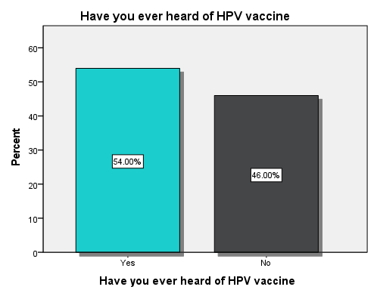

Figure 1Heard of HPV vaccine

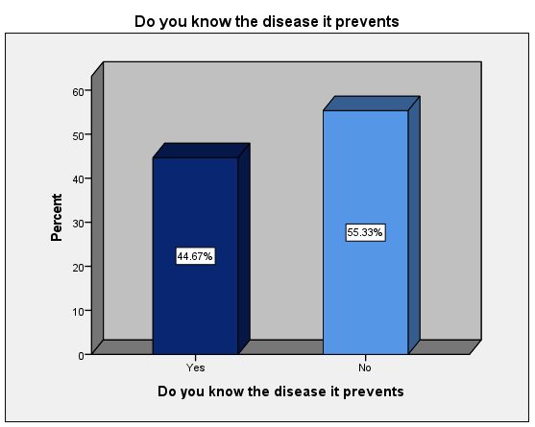

Figure 2Disease HPV vaccine prevents

A significant portion of the population lacked essential knowledge about HPV vaccination, with 112 (74.7%) not knowing the appropriate age group for vaccination, 99 (66%) being unaware of the route of vaccine administration, and 109 (72.7%) not knowing the correct number of doses required.

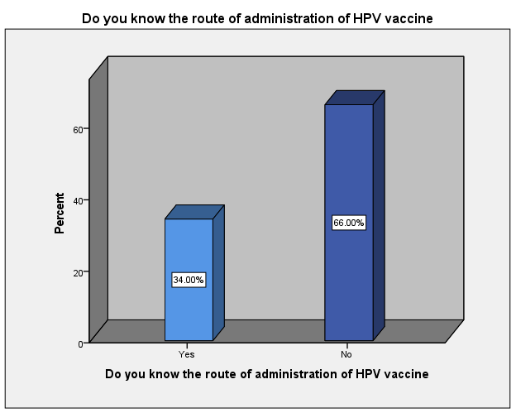

Figure 3Route of administration of HPV vaccine

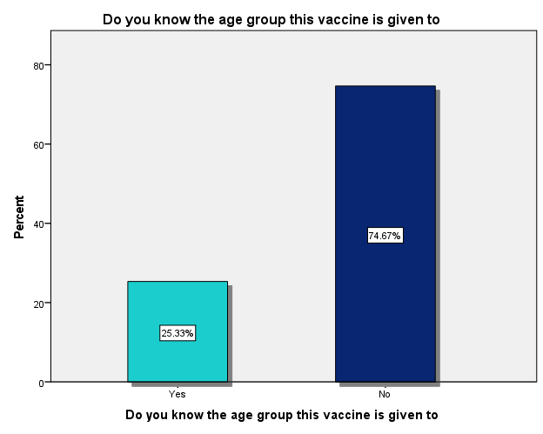

Figure 4Age group recommended for HPV vaccine

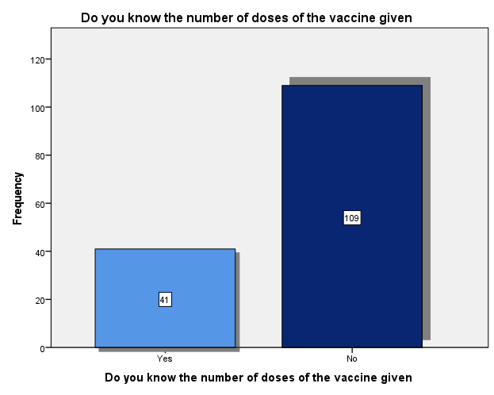

Figure 5Number of HPV vaccine doses administered

A notable divide exists, with 74 (49.3%) expressing belief in its efficacy of the vaccine while 76 (50.7%) hold the view that it is ineffective. Remarkably, 109 (72.7%) are aware of where to access the vaccine, in contrast to 41 ( 27.3%) who lack this information. Of particular concern is that merely 20 (13.3%) of the respondents consider themselves well-informed regarding HPV vaccination, as a substantial majority of 130 (86.7%) acknowledge a deficiency in their knowledge on this subject.

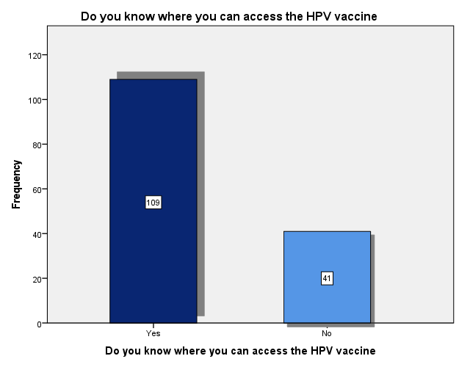

Figure 6 Access to HPV vaccine

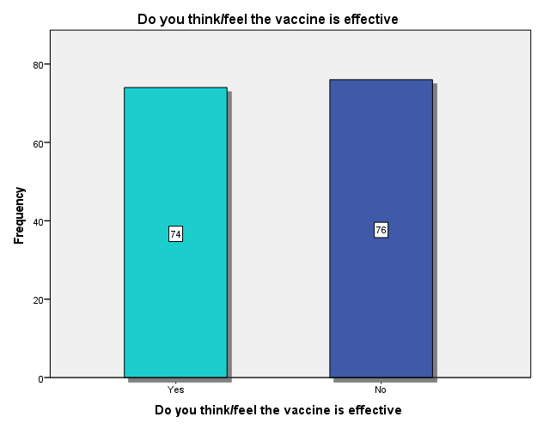

Figure 7 Efficacy to HPV vaccine

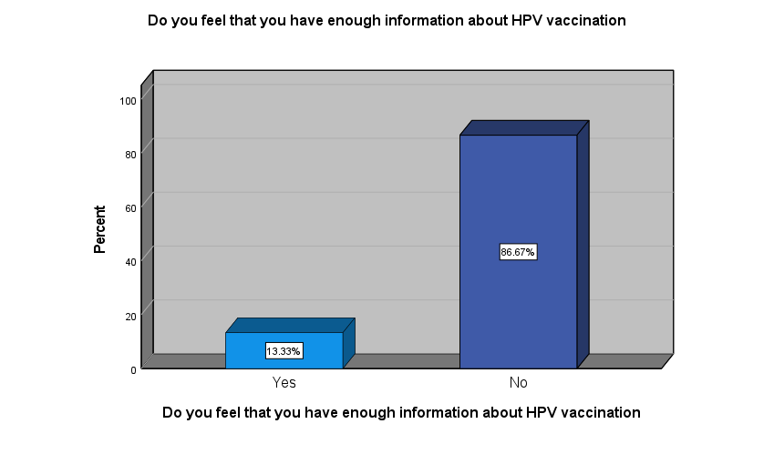

Figure 8 Enough information about HPV vaccination

Regrettably, a significant portion of the participants, 57 (38%) lacked a reliable source of information on HPV. Among those who did have sources, school, social media, and other channels each contributed 16 (10.7%) the Internet accounted for 7 (4.7%) health campaigns for 11 (7.3%) and media (TV and newspapers) for 27 (18%).

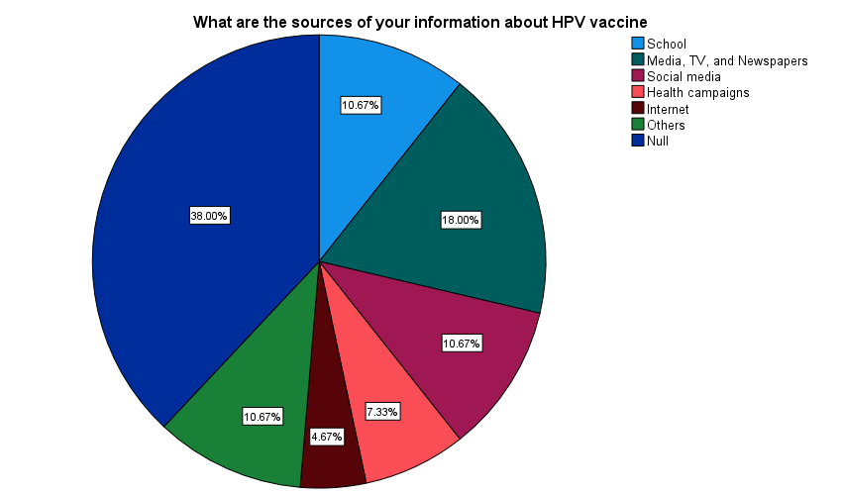

Figure 9 Sources of information

## 4.3 Attitude

A small fraction of the participants, comprising 22 (14.7%) reported declining the HPV vaccine, and their rationales for doing so encompassed multifarious concerns. Notably, 7 (31.8%) expressed the belief that the vaccine served as a form of contraception, while 5 (22.7%) cited concerns regarding potential infertility. Additionally, 2 (9.1%) cited religious reasons, 4 (18.2%) opined that the vaccine might encourage risky sexual behaviors, and another 4 (18.2%) cited general safety concerns as their basis for vaccine refusal.

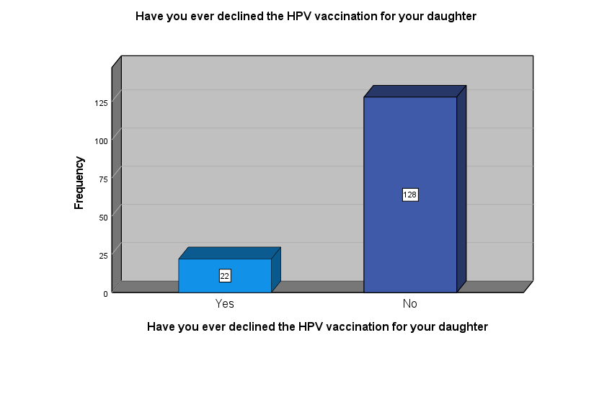

Figure 10 Declining HPV vaccination

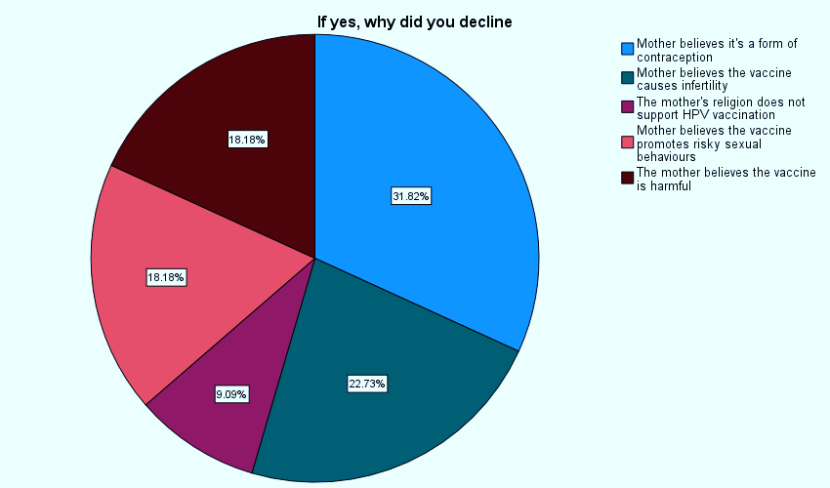

Figure 11 Reason for decliclining HPV vaccine

A substantial portion, 76 (50.7%) admitted to harboring apprehensions concerning HPV vaccination, while 74 (49.3%) reported no such fears. It is noteworthy that 122 (81.3%) expressed a willingness to acquire further knowledge about the vaccine. Intriguingly, 82 (54.7%) believed that the benefits of the vaccine outweigh the associated risks, in contrast to 68 (45.3%) who disagreed with this perspective. In the realm of education, 63.3% of the participants advocated for schools to incorporate HPV-related information into their curriculum, whereas 36.7% held a contrary opinion.

Table 8 Fears regarding HPV vaccine

|  |  |  |
| --- | --- | --- |
| **Fears regarding HPV vaccination for your daughter** | | |
|  | N | % |
| Yes | 76 | 50.7% |
| No | 74 | 49.3% |

Table 9 Willing to have more information

|  |  |  |
| --- | --- | --- |
| **Willing to have more knowledge about the vaccination** | | |
|  | N | % |
| Yes | 122 | 81.3% |
| No | 28 | 18.7% |

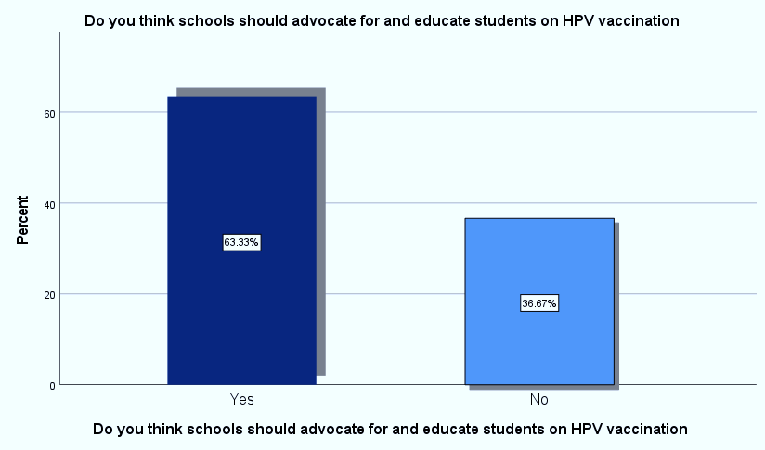

Figure 12 HPV vaccination in schools

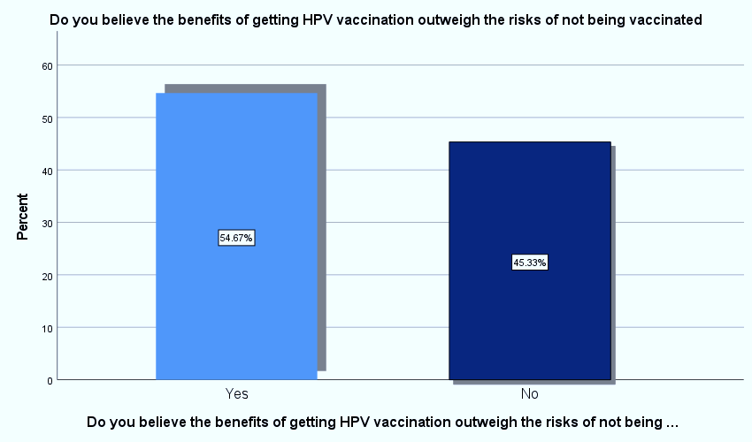

Figure 13 Benefits of HPV vaccine outweigh risks

A diverse spectrum of parental perspectives emerges, with 32 (21.3%) considering HPV vaccination for their daughters as very important, 55 (36.7%) deeming it important, 37 (24.7%) regarding it as not important and 26 (17.3%) remaining uncertain. Furthermore, in terms of discussing sexual knowledge with their daughters, 32% expressed being very comfortable, 42.7% reported feeling comfortable, while 25.3% indicated not comfortable.

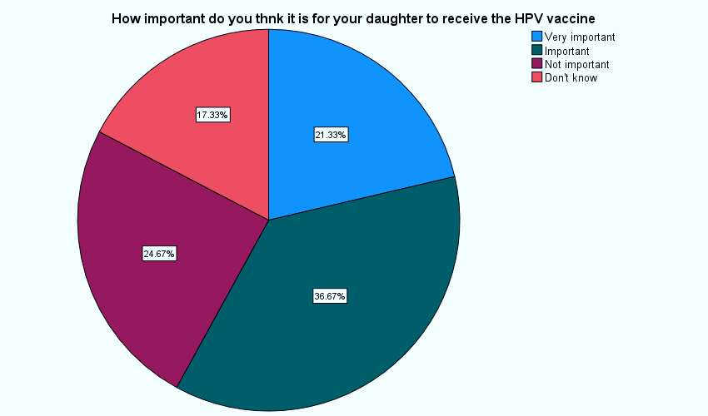

Figure 14 How important it is to vaccinate

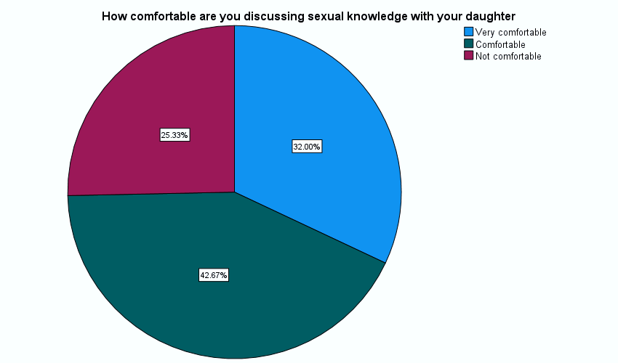

Figure 15 Comfortability of discussing sexual life

## 4.4 Practices

Of the 48 mothers who sought vaccination for their daughters, 28 (58.3%) encountered barriers, including illegal charges (21.4%), healthcare provider reluctance to educate (14.3%), vaccine unavailability (28.6%), long distance and transportation issues (28.6%), and long queue waiting times (7.1%). Also, eight mothers (28.6%) out of 28 who encountered barriers didn’t not vaccinate.

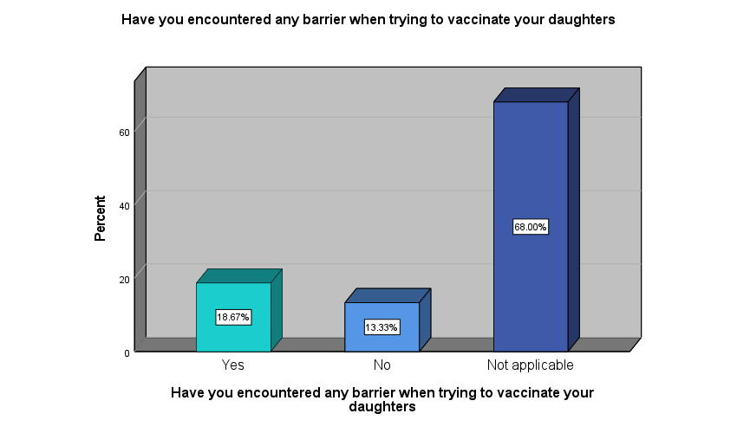

Figure 16 Encountering barriers

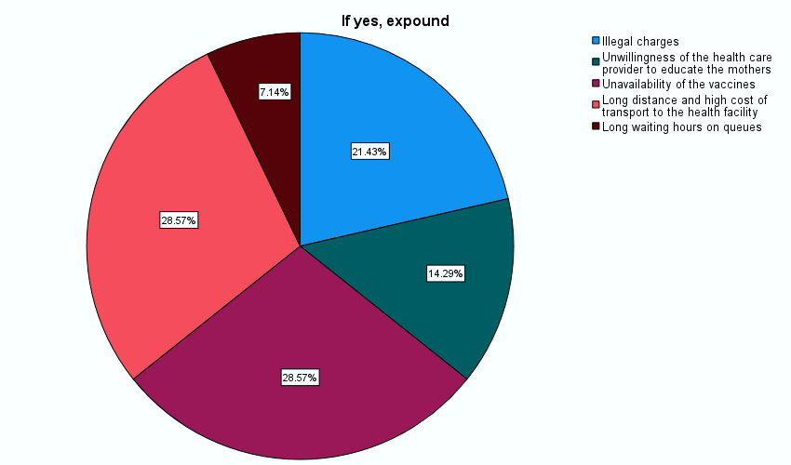

Figure 17 Barriers to HPV vaccination

Within the cohort of mothers who had vaccinated their daughters, 26 %, 13 (33.3%) had administered a single dose, while 26 (66.7%) had provided two doses. Of those receiving only one dose, the rationales were as follows: 2 (15.4% cited) unavailability of the vaccine, 6 (46.2%) indicated that the second dose deadline had elapsed, 3 (23.1%) were awaiting the scheduled time for the second dose, 1(7.6%) reported their child falling ill after the initial dose, and 1 (7.6%) were unaware of the necessity for a second dose.

Table 10 Percentage recipients of HPV vaccine

|  |  |  |
| --- | --- | --- |
| **Has your daughter received the HPV vaccine** | | |
|  | N | % |
| Yes | 39 | 26.0% |
| No | 111 | 74.0% |

Table 11 Number of HPV vaccine dose received

|  |  |  |
| --- | --- | --- |
| **If yes, how many doses** | | |
|  | N | % |
| one | 13 | 33.3% |
| two | 26 | 66.7% |

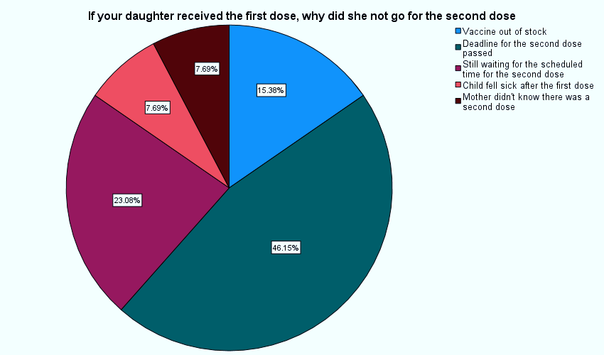

Figure 18 Reasons for not receiving second dose of HPV vaccine

Among the 111 (74%) mothers who had not vaccinated their daughters only 20 (18%) expressed intentions to consider future vaccination, while the majority, 91 (82%) had no such plans. Notably, merely 30.7% of these mothers had ever inquired with their healthcare provider about the HPV vaccine.

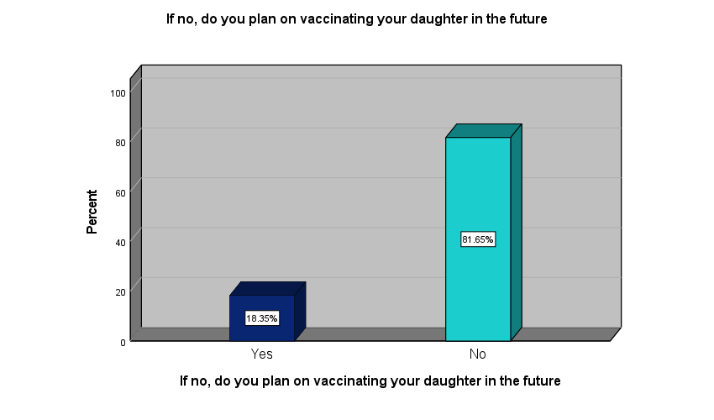

Figure 19 Plan to vaccine in future

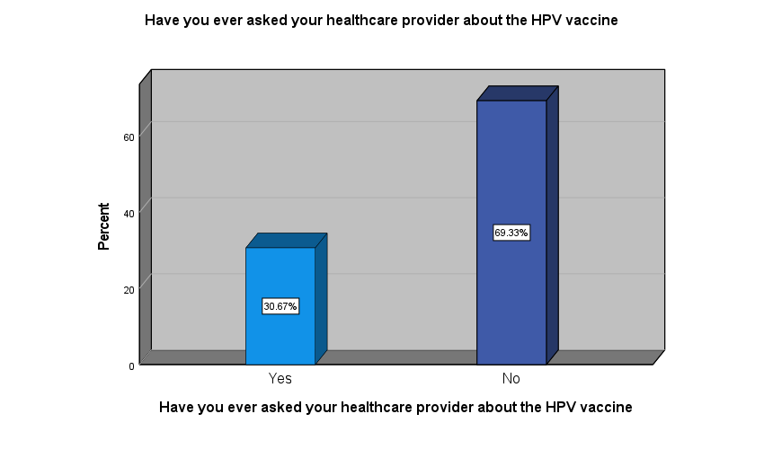

Figure 20 Asking Health care provide about HPV vaccination

Moreover, among the 39 individuals who underwent vaccination, 21 (53.8%) expressed a high degree of satisfaction with the process, 13 (33.3%) reported being satisfied, and a mere 5 (12.8%) indicated dissatisfaction with their vaccination experience.

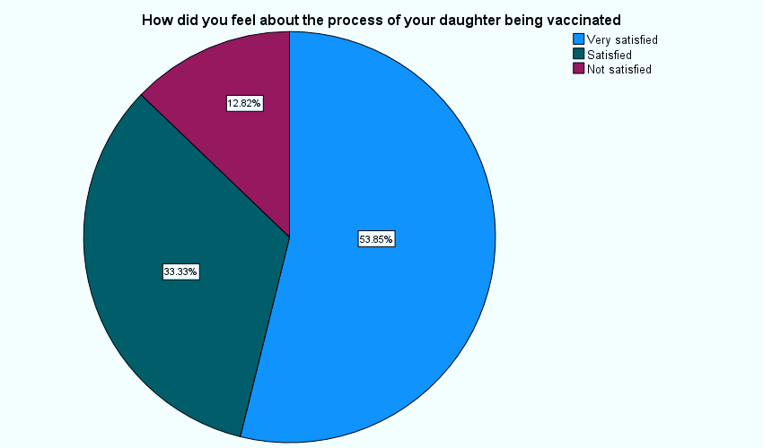

Figure 21 Satisfaction with the process of HPV vaccination

Furthermore, only 44 (29.3%) of mothers feel confident recommending the HPV vaccine to mothers of pre-teen girls, and merely 22 (14.7%) have previously participated in HPV vaccination studies.

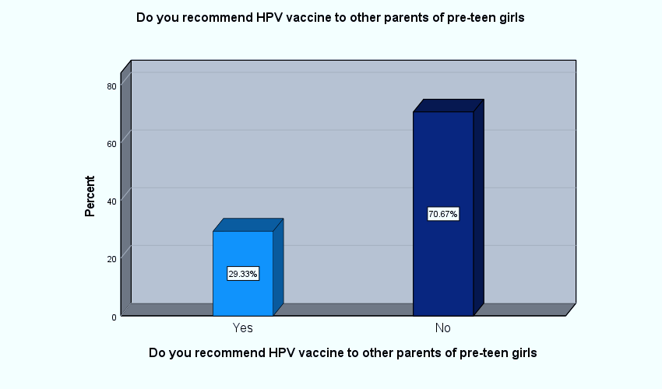

Figure 22 Do you recommend HPV vaccine

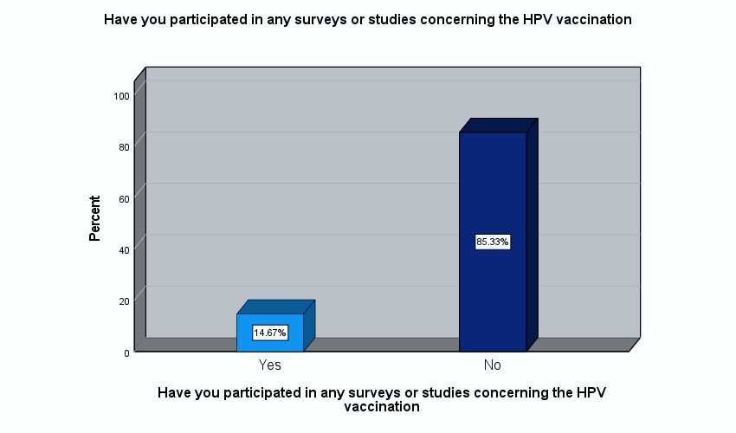

Figure 23 Participation in surveys

## 4.4 Correlation Between Different Variables

Among the surveyed mothers, 31 out of 59 who reported awareness of the disease held tertiary-level education, while merely 3 out of 59 had completed primary education.

Table 12 Education level vs Disease HPV causes

|  |  |  |  |  |
| --- | --- | --- | --- | --- |
| **Education level of the participant * Do you know the disease it causes** | | | | |
|  | | Do you know the disease it causes | | Total |
| Yes | No |
| Education level of the participant | Primary level | 3 | 46 | 49 |
| Secondary | 25 | 39 | 64 |
| Tertiary | 31 | 6 | 37 |
| Total | | 59 | 91 | 150 |

Out of 39 girls who received the vaccine, 23 were born to mothers with at least a tertiary education, while only one out of 39 had a mother with just primary education.

Table 13 Education level vs receiving HPV vaccine

|  |  |  |  |  |
| --- | --- | --- | --- | --- |
| **Education level of the participant * Has your daughter received the HPV vaccine** | | | | |
|  | | Has your daughter received the HPV vaccine | | Total |
| Yes | No |
| Education level of the participant | Primary level | 1 | 48 | 49 |
| Secondary level | 15 | 49 | 64 |
| Tertiary | 23 | 14 | 37 |
| Total | | 39 | 111 | 150 |

Mothers who held tertiary education were more distributed between age brackets 25-35 years (13 mothers or 35.2%) and 35-45 years (22 mothers or 59.6%).

Table 14 Age vs level of education

|  |  |  |  |  |  |
| --- | --- | --- | --- | --- | --- |
| **Age of the participant * Education level of the participant** | | | | | |
|  | | Education level of the participant | | | Total |
| Primary level | Secondary level | Tertiary |
| Age of the participant | Below 25 years | 3 | 2 | 0 | 5 |
| 25-35 years | 16 | 25 | 13 | 54 |
| 35-45 years | 12 | 24 | 22 | 58 |
| 45-55 years | 12 | 13 | 2 | 27 |
| Above 55 years | 6 | 0 | 0 | 6 |
| Total | | 49 | 64 | 37 | 150 |

The majority of mothers who opted against HPV vaccination for their daughters were distributed within two age brackets, 35-45 years, comprising 11 or 50% and 25-35 years, encompassing 7 or 31.8%. The two age groups were prominent within our studied population.

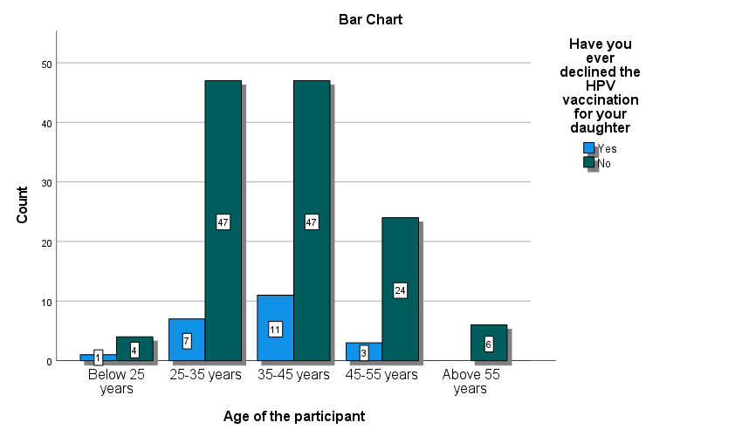

Figure 24 Age vs declining HPV vaccine

The number of mothers who had vaccinated their daughters increased from 14 to 21 for mothers of age bracket 25-35 and 35-45 years. Then, it decreased to only four for mothers aged 45-55 years.

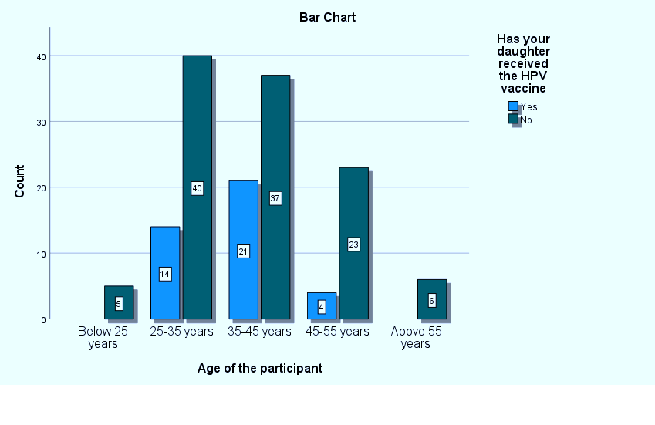

Figure 25 Age vs receiving HPV vaccine

Majority of the mothers (31 or 79.5%) who had vaccinated their daughters came were married in contrast to only (8 or 20.5%) from single mothers.

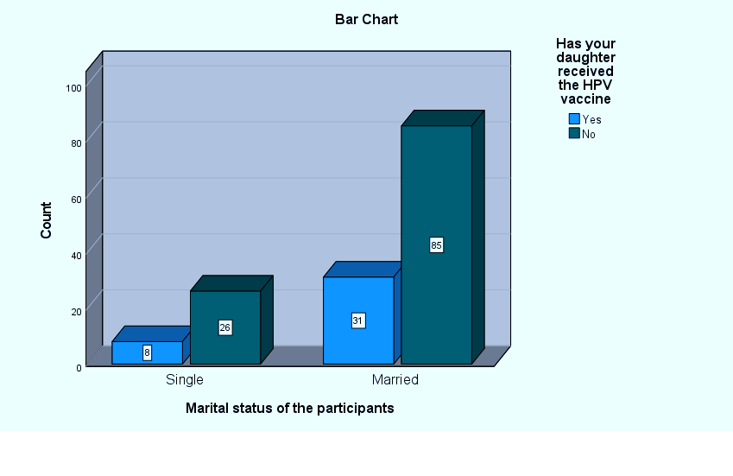

Figure 26 Marital status vs receiving HPV vaccine

Thirty seven out of 39 (94.9%) who vaccinated their daughters were Christian while two or 5.1% were non-Christians

Table 15 Religion vs receiving HPV vaccine

|  |  |  |  |  |
| --- | --- | --- | --- | --- |
| **Religion of the participant * Has your daughter received the HPV vaccine** | | | | |
|  | | Has your daughter received the HPV vaccine | | Total |
| Yes | No |
| Religion of the participant | Christian | 37 | 88 | 125 |
| Non-Christian | 2 | 23 | 25 |
| Total | | 39 | 111 | 150 |

A striking endorsement for HPV vaccine is apparent as 97.4% (38 out of 39) of mothers whose daughters received the vaccine would advocate for it to fellow mothers. In contrast, only 5.4% (6 out of 111) of mothers whose daughters remained unvaccinated expressed a similar recommendation.

Table 16 Receiving HPV vs recommending to others

|  |  |  |  |  |
| --- | --- | --- | --- | --- |
| **Receiving HPV vaccine * Recommend to other mothers** | | | | |
|  | | Do you recommend HPV vaccine to other parents of pre-teen girls | | Total |
| Yes | No |
| Has your daughter received the HPV vaccine | Yes | 38 | 1 | 39 |
| No | 6 | 105 | 111 |
| Total | | 44 | 106 | 150 |

The entire cohort of 22 maternal participants who had previously participated in similar study surveys indicated their knowledge of the human papillomavirus (HPV).

Table 17 Heard of HPV vaccine vs participating in surveys

|  |  |  |  |  |
| --- | --- | --- | --- | --- |
| **Heard of HPV vaccine * Have you participated in similar surveys** | | | | |
|  | | Have you participated in any surveys or studies concerning the HPV vaccination | | Total |
| Yes | No |
| Have you ever heard of HPV vaccine | Yes | 22 | 39 | 61 |
| No | 0 | 89 | 89 |
| Total | | 22 | 128 | 150 |

Thirty one out of 39 mothers whose daughters were vaccinated reported that they knew the disease human papillomavirus causes.

Table 18 Knowing disease HPV causes vs receiving vaccine

|  |  |  |  |  |
| --- | --- | --- | --- | --- |
| **Knowing the disease it causes * Has your daughter received the HPV vaccine** | | | | |
|  | | Has your daughter received the HPV vaccine | | Total |
| Yes | No |
| Do you know the disease it causes | Yes | 31 | 28 | 59 |
| No | 8 | 83 | 91 |
| Total | | 39 | 111 | 150 |

Among the 28 mothers who encountered obstacles, nine had their daughters unvaccinated, in contrast to the absence of unvaccinated daughters among those who did not face any challenges.

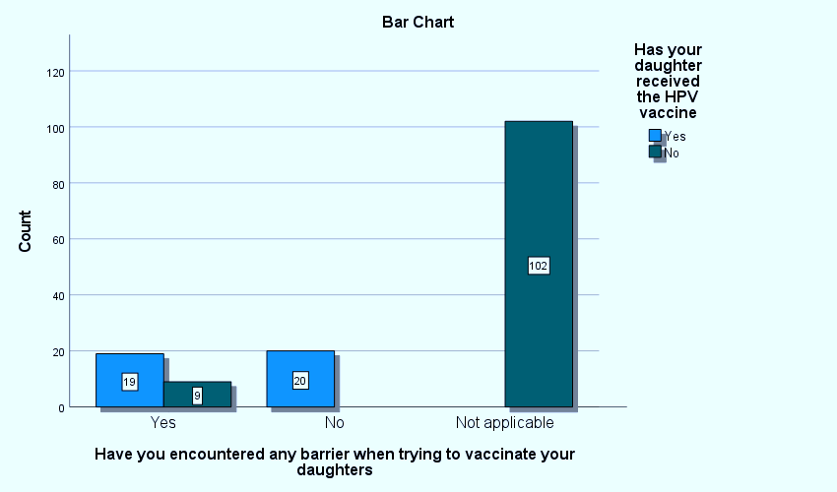

Figure 27 Encountering barrier vs receiving HPV vaccine

Twenty out of 22 mothers who declined HPV vaccination for their daughters had fears regarding HPV vaccine.

Table 19 Declining HPV vaccination vs fears about the vaccine

|  |  |  |  |  |
| --- | --- | --- | --- | --- |
| **Declining HPV vaccination for your daughter * Do you have any fears** | | | | |
|  | | Do you have any fears regarding HPV vaccination | | Total |
| Yes | No |
| Have you ever declined the HPV vaccination | Yes | 20 | 2 | 22 |
| No | 56 | 72 | 128 |
| Total | | 76 | 74 | 150 |

Thirty two out of thirty 39 (82.1%) of mothers who had vaccinated their daughters reported to have heard of HPV vaccine compared to 7 (17.9%) who had not heard about the vaccine.

Table 20 Heard of HPV vaccine vs daughter receiving vaccine

|  |  |  |  |  |
| --- | --- | --- | --- | --- |
| **Have you ever heard of HPV vaccine * Has your daughter received the HPV vaccine** | | | | |
|  | | Received the HPV vaccine | | Total |
| Yes | No |
| Ever heard of HPV vaccine | Yes | 32 | 29 | 61 |
| No | 7 | 82 | 89 |
| Total | | 39 | 111 | 150 |

Majority of the mothers who registered not comfortable discussing sexual life with their daughters had only attained primary level education compared to only four who held tertiary qualifications.

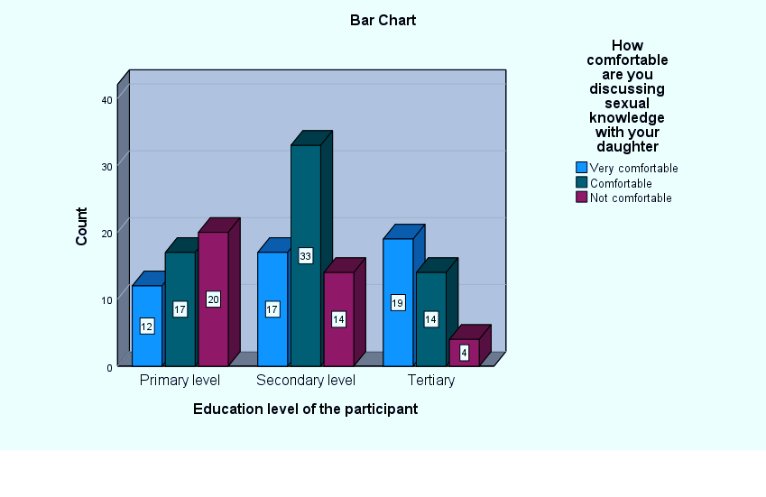

Figure 28 Level of education vs comfort of discussing sexual life with daughter

Thirty six out of 39 mothers who had vaccinated their daughters reported to be comfortable discussing sexual life with their daughters, in contrast to only three who were not comfortable.

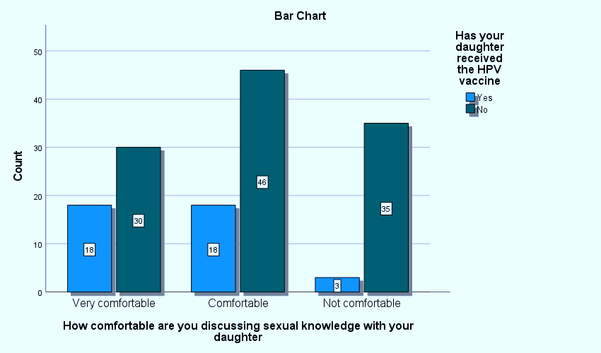

Figure 29 Comfortability of discussing sexual life vs receiving HPV vaccine

# CHAPTER 5: DISCUSSION, CONCLUSION, CHALLENGES, and RECOMMENDATIONS

## 5.1 Discussion

HPV is a serious public health concern. The development of an effective and safe vaccine has been one of the most important achievements in the fight against HPV. However, acceptance of the vaccine by the public is yet to be achieved despite the increasing literature evidence supporting the vaccine effectiveness and safety. According to the analysis of the results HPV is not a common knowledge among mothers of preteen girls attended to at Kitale county hospital with less than half hearing about HPV.

**Demographic features**

Our study noted that increasing maternal age corresponded to increased knowledge about HPV and increased willingness to vaccination up to a certain age where an increasing maternal age was accompanied by inadequate knowledge on HPV, and decreased willingness to vaccinate this differs with a study in Poland where maternal age did not affect the mother’s attitude towards vaccination of their daughters. Our finding also differs with the findings of Chen et al (2023) which showed that the older the mother the higher possibilities of daughters’ vaccination because older mothers had more knowledge unlike in our study where older mothers had the least knowledge.

Our study found out that those who reached tertiary level of education were more likely to know about HPV (51%), and more likely to vaccinate their daughters (58%). Sinshaw et al., (2022) also found out that mothers who had a degree or diploma were more likely to have a good knowledge on HPV, and were more likely to vaccinate their daughters than mothers who attended primary or secondary schools. This was also a finding in another studies (Chen.L et al, 2023; Charakorn et al ,2011; Gerend and Shepherd, 2011; Tiro et al, 2007), but differs Krawczyk’s study, which did not reveal any correlation between parents’ education and vaccination among Quebec families, which could have been due to a history of vaccine uptake there

The high vaccine uptake with people of higher education background could have been due to their greater understanding of HPV and possession of more accurate health beliefs and knowledge and therefore will make a more positive health related choice.

**Knowledge**

Only 40% of the participants had heard of HPV virus and, a similar percentage were familiar with the vaccine which is slightly lower than the findings of a study by Ogengo (2021) revealed that 59.5% of the participants had heard of the HPV vaccine, 31.4% knew about the HPV virus.

Ogengo (2022) also found out that only 19.9 % of its participants knew that HPV was transmitted through sexual contact which differs with the findings our study which found out that 34.7 % knew about the mode of HPV transmission .In our study we found out that 34% were aware of the route of vaccination and 27.8% did not know the number of doses administered which differs with the findings of Mercy Ogengo of 53.2% knowing its mode of administration was via injection and only 18 % knew about the number of doses administered. This is in agreement with our study, 34%.

Another study in Ethiopia (Sinshaw et al, 2022) is in agreement with our study, where it found out that only 47.6% had knowledge on HPV, 33.6% of the participants knew that HPV was transmitted through sexual contact which is similar to another study conducted in Malaysia (32.8%) but it is lower from the findings of studies in Indonesia (52%), Brazil (82%) and India (97.5%) and Mburu et al in a study in Eldoret Kenya found that only 17,2% of the participants identified HPV as sexually transmitted, which is even lower than our findings.

Almost half of the participant expressed belief in the efficacy of the vaccine (49.3%) which was also findings of an earlier study conducted in Malayasia (Rashwan et al, 2009) which 49.1 % believed the vaccine was effective.

Our study found out that only 13.3% of the mothers had been confident that they have enough about HPV vaccination which is in agreement with research done by (Kolek et al,2022) which found out that less than 30% were well informed about HPV vaccine.

In our study the major source of information on HPV was media (television and newspapers) 29%, 7% by internet and 11.8% through health campaigns which are similar to findings of a study in Bangladesh that had the media as the major source of information (46.3%) These findings differ with the finding of a study in India (G. Shivani and M. Rajakeshmi 2021), which found out that the internet was the highest source of information at 39.3% and television the lowest at 2.5%. Our study found out that health professional played a little role as the source of information (7.3%) which was also a finding by Kumari S et al (2021) (3.2%) whereas in a study in Thailand (Juntasopeepun et al) Health professionals were the main source of information.

**Attitude**

Greater than four fifths of the participants (85.3%) had a positive attitude towards the HPV vaccine (had never declined HPV vaccination) which is also found in studies in Ethiopia (74%) (Sinshaw et al,2022) and Kenya (63.3%) (Ogengo,2021). Of the participants that reported to have declined HPV vaccination the majority cited the belief of the vaccine being a form of a contraception, 31.8%. This is in agreement with a study done in Tana River and Mombasa counties by Njuguna et al found out that 45% of the participants believed that the vaccine was a form of birth control.

We found out that half of the participants harbored fears towards the vaccine (50.7%) which was similar finding in a study in Finland (48.5%) (Yesaya et al, 2020).

We also found out that 81.3 % were willing to acquire further knowledge on the vaccine which was in agreement with the findings of by Kolek et al (2022) that found out that 90% of the participants expressed an interest in knowing more about the HPV vaccine which are higher than the findings of Yesaya et al (2020) of 62%.

The desire for more information is an opportunity for increasing HPV vaccine uptake. More than half of the participants (58%) thought that HPV vaccination was important for their daughters and more than half (54.7%) believed the vaccine had more benefits than risk which was lower than the findings of a study carried out in Greece (Naoum et al, 2022) (77%) believing the vaccine is important and its benefits outweigh the risks. It’s most likely that the mothers’ positive attitude towards the HPV vaccination was more intuitive than reasoned based on the mix of level of knowledge.

**Practices**

Less than one third of the participants reported to have vaccinated their daughters either fully or with one dose (26%), which is similar to a study by Karanja Chege (2022) that found out that the uptake of the HPV vaccine was as low as 25% in 2019 and increased to 33% by 2020.

More than half of the mothers (58.3%) who sought vaccination for their daughters’ encountered barriers with the major barriers being vaccine availability, long distance and transport costs accounting for 57.2% of the barriers which was also a finding by Vermandere et al (2012). Lack of knowledge accounted for one of the major reasons of not vaccinating which is similar to the findings of Chen et al, 2023.

We found out that 74% of all those vaccinated received full doses (2). This is higher than the findings of Naoum et al, (2022) who found out that only 36% of the participants daughters were fully vaccinated.

About a half of the reasons of the daughters of the participants getting one dose was age factors (49.3%) and only 14% was due to safety concerns and lack of enough knowledge (7% each) this is different from the study Yun where 41% of the reasons for not vaccinating or going for the second dose was due to safety concerns.

97.4% of all mothers whose daughters were vaccinated would recommend the HPV vaccine to other mothers which corroborates with the findings of Sinshaw et al (2022) that found out that mothers who had good knowledge and had vaccinated their daughters were three times more likely to recommend the vaccine to other mothers.

The findings of the current study shows that maternal education level, the higher knowledge of HPV and HPV vaccine and the perception of the importance of HPV vaccination vaccine played a bigger role in vaccination of their daughters. This concurs with the studies of Sinshaw et al (2022) and Chen et al (2023) which found out that the mother who had good knowledge about the vaccine had a better attitude and practice towards the HPV vaccination than mothers who had less knowledge about the vaccine which also corroborates with the findings of Watson et al.

Based on the findings of this study, confirms that optimal coverage of. HPV vaccination is yet to be achieved.

The role of health care professionals and schools has been highlighted to be among the underutilized sources of information and awareness about HPV despite them being a significant factor in the parents’ decision to vaccinate their daughter against HPV which can be utilized in order to increase public acceptance of the vaccine. Although the vaccination rate was low it was encouraging to find that most of the mothers had a positive attitude towards HPV vaccination.

## 5.2 Conclusion

In conclusion, there is a notable gap in the knowledge and awareness among mothers regarding HPV vaccination for their pre-teen daughters attending Kitale County Referral Hospital. Majority of the sample population did not have comprehensive knowledge about the HPV, the disease it causes and it’s mode of transmission.

Furthermore, a significant proportion of the surveyed mothers were unfamiliar with the HPV vaccine, the number of doses usually given, and the age group that is usually vaccinated. Attitudes toward HPV vaccination were diverse, with a fraction of mothers expressing fears, including misconceptions about the vaccine's role and safety. The practices related to HPV vaccination revealed barriers and gaps in administration, with a substantial number of mothers reporting their daughters had not received the vaccine. The correlation analysis also highlighted the importance of information sources in increasing knowledge about HPV. These findings underscore the need for targeted educational interventions to improve awareness and knowledge about HPV vaccination among mothers in this population, with a focus on addressing misconceptions and barriers to vaccination.

## 5.3 Challenges

The research process was not without its shares of challenges. Outlined below are the challenges we faced during the process.

1. **Language barrier**

One of the foremost challenges we encountered was the language barrier. Kitale is a rural area and accommodates different groups of people who speak different languages. The predominant language spoken is Luhya, another common language spoken is Kalenjin, but since the hospital serves a wide area there are people who come from West Pokot, others are refugees from Uganda and Congo. Some of the locals do not understand the national language which is Swahili. Engaging with the local population and collecting data became a challenging task due to this language barrier. To mitigate this challenge, we collaborated with local interpreters and translated our research materials to the local language.

1. **Reluctance to participate**

Another significant challenge was the reluctance of potential participants. The research was conducted within a hospital setting, and many individuals present at the hospital had health concerns, either as patients or caregivers. This often led to their reluctance to participate in our study. We addressed this issue by considering alternative locations like outside the wards and times for data collection and by emphasizing the research's potential health benefits for the community.

1. **Lack of analytical skills**

A crucial challenge was the lack of analytical skills, particularly concerning the use of statistical analysis software such as SPSS. Our team had not received training in data analysis, which hindered the data processing and interpretation process. We recognize the importance of obtaining proper training or seeking expert guidance for future research endeavors.

1. **Financial constraints**

Financial constraints also posed a challenge. Participants often requested incentives for their involvement, which we were unable to provide due to limited resources. To address this issue, we explained how important their participation in the research was even though there were no incentives. We also explained to them that we had limited resources.

1. **Exclusion and inclusion criteria**

Identifying the specific cohort of mothers with daughters aged between 9-12, who constituted our research's target population, presented a significant challenge. The process of pinpointing this particular demographic within the larger study sample required diligent effort and precision. Nevertheless, our commitment to accurately representing the group's perspectives and experiences contributed to the research's thoroughness and the accuracy of its insights.

Despite these challenges, our research project aimed to shed light on a critical health issue in the Kitale community. Overcoming these obstacles required perseverance, creativity, and adaptability. The experience gained in addressing these challenges, while challenging, was instrumental in our development in research.

## 5.4 Recommendations

1. Increase exposure to information via different sources especially health campaigns, community mobilization, health education, and public media.
2. Linking sexual health education in schools to HPV vaccination to ensure people have knowledge about HPV vaccination from a younger age.
3. Health care provider recommendation of the vaccine to mother's when they bring their pre- teen girls to the hospital through screening for the patient's immunization records.
4. Set reminders for mothers whose girls have received the first dose, to be sent through phone calls, text messages and emails.
5. Equip peripheral health centers with the vaccine to increase accessibility for girls living in remote areas.
6. Inform mothers on HPV vaccination in advance during their children's early life vaccination programs
7. Work hand in hand with community leaders and village elders to help reduce the negative practices and false beliefs about the HPV vaccine.
8. Conduct more studies and surveys on HPV vaccination to help identify more challenges and come up with solutions to increase vaccine uptake.

# APPENDICES

## Appendix I: Schedule of activities

|  |  |  |  |  |  |  |
| --- | --- | --- | --- | --- | --- | --- |
| **Project activity** | **Dec 2022-Jan 2023** | **February 2023** | **March**  **2023** | **April-May2023** | **Sep-October 2023** | **November 2023** |
| **Brainstorm & finding research problem** | ✔ |  |  |  |  |  |
| **Formulating & approval of topic** |  | ✔ |  |  |  |  |
| **Writing research proposal** |  | ✔ | ✔ |  |  |  |
| **Formulate questionnaire & data collection** |  |  |  | ✔ | ✔ |  |
| **Analyzing data** |  |  |  |  | ✔ | ✔ |
| **Research presentation** |  |  |  |  |  | ✔ |

## Appendix II: Research Budget

|  |  |
| --- | --- |
| **ITEM** | **TOTAL** |
| Printing papers and stationery | 700 |
| Printing and binding | 2600 |
| Transportation | 1500 |
| Participant incentives | 2600 |
| Data analysis tools | 1500 |
| Software licenses | 2500 |
| Miscellaneous expenses | 500 |
| Laptop | 30,000 |
| **Total** | **Ksh41, 900** |

## 

## Appendix III: Consent Form

You are being asked to take part in a research study that aims to investigate pre-teenage mothers' knowledge, attitudes, and practices regarding HPV vaccination at Kitale County Referral Hospital in Kenya. If you choose to participate, you will be given a survey/questionnaire about HPV vaccination that will take around 20 minutes to complete. There are no known risks associated with participating, and the benefits include contributing to the understanding of HPV vaccination among pre-teen mothers in Kenya. Your responses will be kept confidential, and your name will not be used in any reports or publications. Your participation is voluntary, and you may withdraw from the study at any time without penalty or loss of benefits. By signing below, you indicate that you have understood the information provided and agree to participate in the study.

Participant 1

Signature Date

## Appendix IV: Questionnaire

**Knowledge, Attitude, and Practices of HPV Vaccination among Mothers of Pre-teen Age Girls Attended to at Kitale County Referral Hospital.**

**Demographic features**

1. How old are you?

1.<25 years___ 2. 25-35 years __ 3. 35-45 years 4. 45-55 years 5. >55 years

1. What is your education level?

1. Primary level ___ 2. Secondary level___ 3. Tertiary level

1. What is your marital status?

1. Single___ 2. Married

1. What religion do you associate yourself with?

1. Christian__ 2. Non-christian

**KNOWLEDGE**

1. Have you ever heard of HPV? 1. Yes__ 2. No___
2. Do you know the disease it causes? 1.Yes___ 2. No __
3. Do you know how HPV is transmitted? 1. Yes __ 2. No___
4. Have you ever heard of HPV vaccine? 1. Yes __ 2. No__
5. Do you know the disease it prevents? 1. Yes___ 2. No ___
6. Do you know the age group this vaccine is given to? 1. Yes__ 2. No___
7. Do you know the route of administration of HPV vaccine? 1. Yes___ 2.No___
8. Do you know the number of doses of the vaccine given? 1. Yes __ 2. No___
9. Do you think/feel the vaccine is effective? 1. Yes____ 2. No____
10. Do you know where you can access the HPV vaccine? 1. Yes___ 2. No___
11. Do you feel that you have enough information about HPV vaccination?
12. Yes___ 2. No ___
13. What are the sources of your information about HPV vaccine?

1. School__ 2. Media TV & Newspapers __ 3. Social Media __ 4. Health Campaigns __ 5. Internet ___ 6. Others __ 7. Null

**ATTITUDE**

1. Have you ever declined the HPV vaccination for your daughter?

1. Yes___2. No__

If yes Why____

1. Do you have any fears regarding HPV vaccination for your daughter?

1. Yes __2. No___

1. Would you be willing in having more knowledge about the vaccination?
2. Yes___ 2. No ____
3. How important do you think it is for your daughter to receive the HPV vaccine?

1. Very Important___ 2. Important ___

3. Not Important ____ 4. Don’t Know ____

1. Do you believe the benefits of getting HPV vaccination outweigh the risks of not being vaccinated? 1. Yes___ 2. No____
2. Do you think schools should advocate for and educate students on HPV vaccination? 1. Yes____ 2. No___
3. How comfortable are you discussing sexual and HPV vaccine with your daughter?
4. Very Comfortable___ 2. Comfortable ____ 3. Not comfortable ____

**PRACTICES**

1. Have you encountered any barrier when trying to vaccinate your daughters?

1. Yes ___ 2. No____ 3. Not applicable____

If yes, expound _____

1. Has your daughter received the HPV vaccine? 1. Yes ____ 2. No____
2. If yes, how many doses _____ 1. One___ 2. Two ___
3. If no, do you plan on vaccinating your daughter in the future

1. Yes ___ 2. No ___

1. If your daughter received the first dose, why did she not go for the second dose?_______
2. Have you ever asked your health care provider about the HPV?

1. Yes____ 2. No ___

1. How did you feel about the process of your daughter being vaccinated?

1. Very satisfied ___ 2. Satisfied ____ 3. Not Satisfied ____ 4. Not applicable

1. Do you recommend HPV vaccine to other parents of preteen girls?

1. Yes___ 2. No___

1. Have you participated in any surveys or studies concerning HPV vaccination?
2. Yes ___2. No___

# 

# REFERENCES

Akbari, M., Ghanbarzadeh, N., Javadzadeh Shahshahani, H., & Gholamin, S. (2020). *Knowledge, Attitude, and Practice towards Human Papillomavirus Vaccination among Mothers in Iran: A Systematic Review.* Asian Pacific Journal of Cancer Prevention, 21(6), 1539-1549.

Btoush, R., Brown, D. R., Tsui, J., Toler, L., &amp; Bucalo, J. (2019, May 30). *Knowledge and attitudes toward human papillomavirus vaccination among Latina Mothers of South American and Caribbean descent in the eastern US. Health equity.* Retrieved February 5, 2023.<https://www.ncbi.nlm.nih.gov/pmc/articles/PMC6608702/>

Centers for Disease Control and Prevention. (2021, July 23). *HPV vaccine*. Centers for Disease Control and Prevention. Retrieved March 18, 2023, from https://www.cdc.gov/hpv/parents/vaccine-for-hpv.html

Chen, L., Sun, X., Luo, J., Zhang, Y., Ha, Y., Xu, X., Tao, L., Mu, X., Gao, S., Han, Y., Wang, C., Wang, F., Wang, J., Yang, B., Guo, X., Yu, Y., Ma, X., Liu, L., Ma, W., … Cui, F. (2023, May 12). *A case-control study on factors of HPV vaccination for mother and daughter in China*. MDPI. <https://www.mdpi.com/2076-393X/11/5/976>

Elit, L., Ngalla, C., Afugchwi, G. M., Tum, E., Domgue, J. F., & Nouvet, E. (2022, November 1). *Assessing knowledge, attitudes, and belief toward HPV vaccination of parents with children aged 9–14 years in rural communities of Northwest Cameroon: A qualitative study*. BMJ Open. Retrieved March 5, 2023, from<https://bmjopen.bmj.com/content/12/11/e068212>

Galbraith-Gyan, K. V., Lechuga, J., Jenerette, C. M., Palmer, M. H., Moore, A. D., & Hamilton, J. B. (2019, April). *HPV vaccine acceptance among African-American mothers and their daughters: An inquiry grounded in culture*. Ethnicity & health. Retrieved March 5, 2023,<https://www.ncbi.nlm.nih.gov/pmc/articles/PMC6175663/>

Humnesa, H., Aboma, M., Dida, N., & Abebe, M. (2022, October 12). *Knowledge and attitude regarding human papillomavirus vaccine and its associated factors among parents of daughters aged between 9-14 years in central Ethiopia, 2021*. Journal of public health in Africa. Retrieved March 5, 2023, https://www.ncbi.nlm.nih.gov/pmc/articles/PMC9614691/

Karanja-Chege, C. M. (2022, March 21). *HPV vaccination in Kenya: The challenges faced and strategies to increase uptake*. Frontiers in public health. Retrieved March 18, 2023, https://www.ncbi.nlm.nih.gov/pmc/articles/PMC8978582/

Kash, N., Lee, M. A., Kollipara, R., Downing, C., Guidry, J., & Tyring, S. K. (2015, April 3). *Safety and efficacy data on vaccines and immunization to human papillomavirus*. Journal of clinical medicine. Retrieved March 5, 2023, https://www.ncbi.nlm.nih.gov/pmc/articles/PMC4470159/

Kenya National Bureau of Statistics. (2019). *Kenya population and housing census volume IV: Distribution of population by socio-economic characteristics.* Retrieved from<https://www.knbs.or.ke/?wpdmpro=2019-kenya-population-and-housing-census-volume-iv-distribution-of-population-by-socio-economic-characteristics>

Kumari, S., Singh, Aradhana, Sangal, R., & Sharma, N. (2021, April 6). Kap study on cervical cancer and human papillomavirus vaccine ... https://www.ijrcog.org/index.php/ijrcog/article/download/10038/6527

Luria, L., & Cardoza-Favarato, G. (2022). *Human Papillomavirus.* In StatPearls. StatPearls Publishing.

Mabeya, H., Odunga, J., & Broeck, D. V. (2021). *Mothers of adolescent girls and human papilloma virus (HPV) vaccination in western Kenya*. The Pan African medical journal. Retrieved March 5, 2023,<https://pubmed.ncbi.nlm.nih.gov/33912296/>

Ministry of Health. (2019). *National Immunization Schedule Kenya.* Retrieved from [https://www.health.go.ke/wp-content/uploads/2021/07/National-Immunization- Schedule-2019.pdf](https://www.health.go.ke/wp-content/uploads/2021/07/National-Immunization-Schedule-2019.pdf)

Ministry of Health. (2020). *Comprehensive Cervical Cancer Control in Kenya National Strategic Plan 2020-2024.* Retrieved from<https://www.health.go.ke/wp-content>

Naoum, P., Athanasakis, K., Zavras, D., Kyriopoulos, J., & Pavi, E. (2022, May 16). *Knowledge, perceptions and attitudes toward HPV vaccination: A survey on parents of girls aged 11–18 years old in Greece*. Frontiers. https://www.frontiersin.org/articles/10.3389/fgwh.2022.871090/full

Njuguna, D. W., Mahrouseh, N., Isowamwen, O. V., &amp; Varga, O. (2021, September 28). The main stakeholders' knowledge, attitude, and practice towards human papillomavirus infection and vaccination in Mombasa and Tana-River counties in Kenya: A qualitative study. Vaccines.<https://www.ncbi.nlm.nih.gov/pmc/articles/PMC8538985/>

Patrick, L., Bakeera-Kitaka, S., Rujumba, J., & Malande, O. O. (n.d.). *Encouraging improvement in HPV vaccination coverage among adolescent girls in Kampala, Uganda*. PLOS ONE. Retrieved March 18, 2023, from https://journals.plos.org/plosone/article?id=10.1371%2Fjournal.pone.0269655

Sinshaw, M. T., Berhe, S., & Ayele, S. G. (2022). Retrieved from https://www.dovepress.com/knowledge-and-attitude-towards-human-papillomavirus-vaccine-and-associ-peer-reviewed-fulltext-article-IDR

Smolarczyk, K., Duszewska, A., Drozd, S., & Majewski, S. (2022, February 2). *Parents' knowledge and attitude towards HPV and HPV vaccination in Poland*. Vaccines. Retrieved March 5, 2023,<https://www.ncbi.nlm.nih.gov/pmc/articles/PMC8876926/>

World Health Organization. (2019). *Human papillomavirus vaccines: WHO position paper, May 2017* – Recommendations. Vaccine, 37(2), 227-229.

Yesaya, D. (2020, November). Knowledge, attitude and practice towards human papilloma virus (HPV ... https://erepo.uef.fi/bitstream/handle/123456789/23898/16073587501680086531.pdf?sequence=1

Zibako, P. *et al.* (2021) *Knowledge, attitude and practice towards cervical cancer prevention among mothers of girls aged between 9 and 14 years: A Cross Sectional Survey in Zimbabwe - BMC Women’s Health*, *BioMed Central*. Available at: https://bmcwomenshealth.biomedcentral.com/articles/10.1186/s12905-021-01575-z (Accessed: 02 November 2023).

Zibako, P., Tsikai, N., Manyame, S., & Ginindza, T. G. (2021, December 20). *Knowledge, attitude and practice towards cervical cancer prevention among mothers of girls aged between 9 and 14 years: A Cross Sectional Survey in Zimbabwe - BMC Women’s Health*. BioMed Central. https://bmcwomenshealth.biomedcentral.com/articles/10.1186/s12905-021-01575-z